**Background and objectives of the project-**

Intelligent Parking Service is a part of Intelligent Parking Systems . The searching of parking burn a lot of barrel of the world oil every day. Car parking problem is a major role in congestion of traffic and has been still a major problem with increasing vehicle size in the luxurious segment and also confine parking spaces in urban cities. The rapid growth in the number of vehicles worldwide is intensifying the problem of the lack of parking space. As the global population continues to urbanize, without a well-planned convenience driven retreat from the car these problems will worsen in many countries. The current unmanaged car parks and transportation facilities make it difficult to accommodate the increasing number of vehicles in a proper, convenient manner so it is necessary to have an efficient and smart parking system. Smart parking management systems are capable of providing extreme level of convenience to the drive. Localization is a key issue of the navigation system to guide unmanned ground vehicle in an intelligent Space. Intelligent Space is an environmental system. This intelligent Space able to support informative and physical ways. The proposed system includes sensors information fusion, position estimation, path planning and tracking. Camera is used to get image information of the robot. Image processing and FPGA embedded together to identify position and orientation of UGV very correctly and accurately. The proposed architecture works on distributed image processing pixels which causes the amount of data to be transmitted through communication network will be minimum.

**Goal and Benefits Analysis of Smart Parking-**

* Optimize parking space usage.
* Help traffic in the city flow more freely.
* Guides residents and visitors to available parking.
* Accurately predict and sense spot/vehicle occupancy in real-time.
* Saving money , time and the stress of searching for vehicle parking.
* Smart parking plays a major role in creating better urban environment by reducing the emission of CO2 and other pollutants.

**Introduction-**

The searching of a parking space in a parking lot in commercial area is a so much frustrating activity for many people. More problem increases with the high growth rate in the registration of new cars worldwide. There are many parking places of modern technologies existing but many drivers don’t know about the parking blocks so this is big challenge for us to acknowledge the people about smart parking which will help to save a lot of fuel and systematizing the parking of vehicles.

To overcome from these problems of congestion of traffic and save the fuels from it, the unique step of solution is smart parking.

• The services which the Intelligent Parking System should provide in the future are-

a. The parking availability information system and parking reservation system should provide advanced navigation services.

b. The mobile electric commerce system and a continuously working gate system should collect the toll charges electrically

c. An automated navigation system should assist in safe driving.

d. An in-facility navigation system should provide the best possible traffic management.

e. Provision of effective security for the safety of cars.

f. Provision of strong functions for facilitating administrators and managers in management of the parking facility.

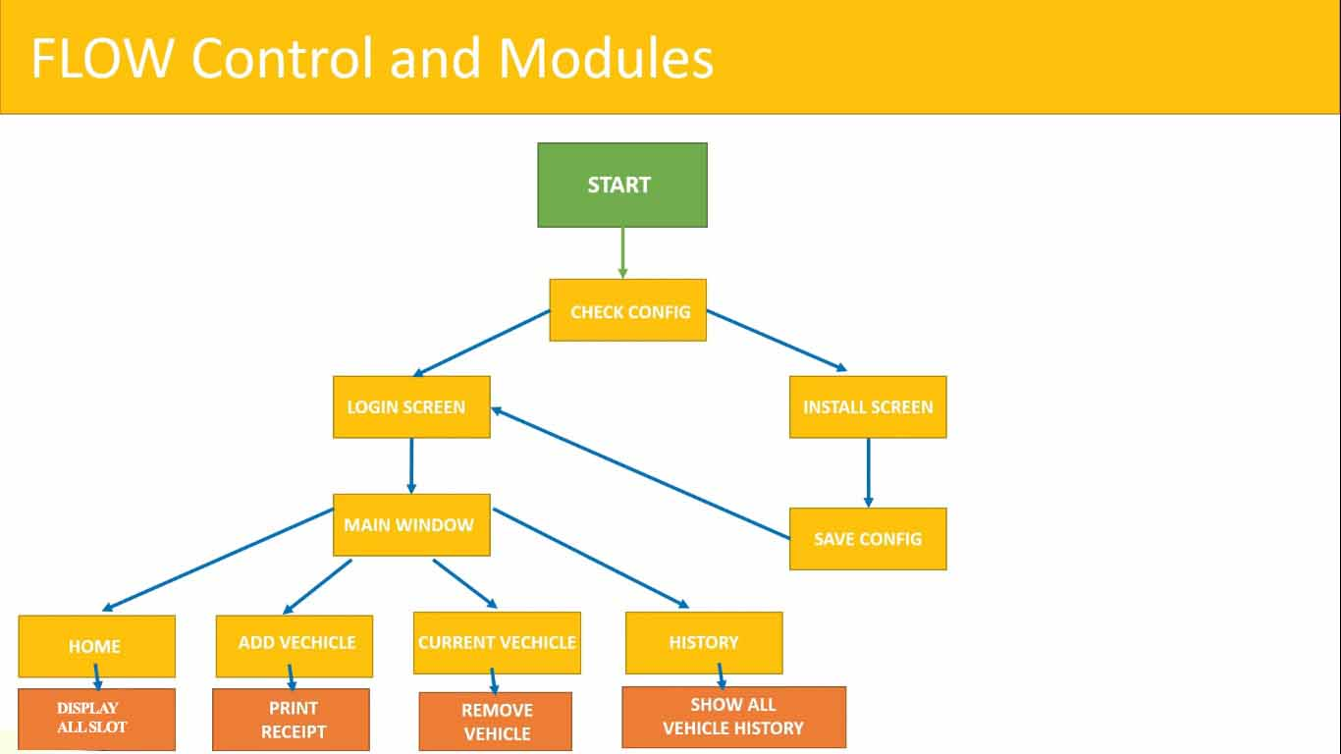

**Login Screen-**

In login screen user required to enter the user-name and password. If user-name and password matches with data base then user promote to HOME WINDOW, else show error message.

LOGIN

PASSWORD

USER-NAME

**Home Window-**

In home window user can see the available places where he can parked vehicle. User has options Add vehicle, Manage vehicle and history.

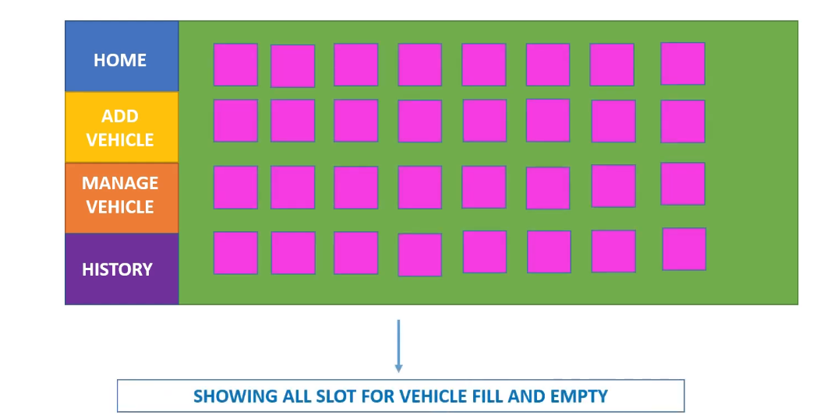

**Add vehicle-**

In this field user have to enter Name, vehicle number and Mobile number.After adding the vehicle successfully user will get receipt.

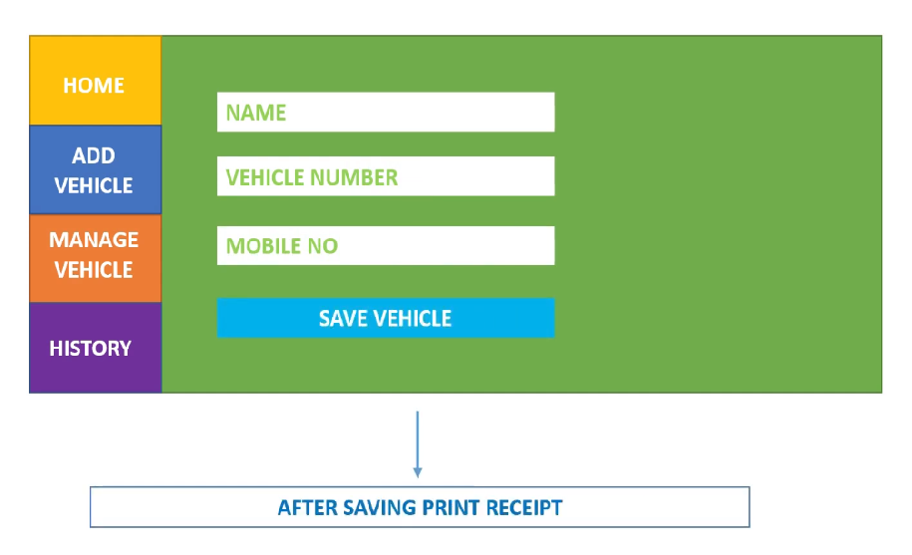

**Manage vehicle-**

In this window user get all data of parked vehicle such as vehicle number, entry time from this window user can take exit action of the vehicle.

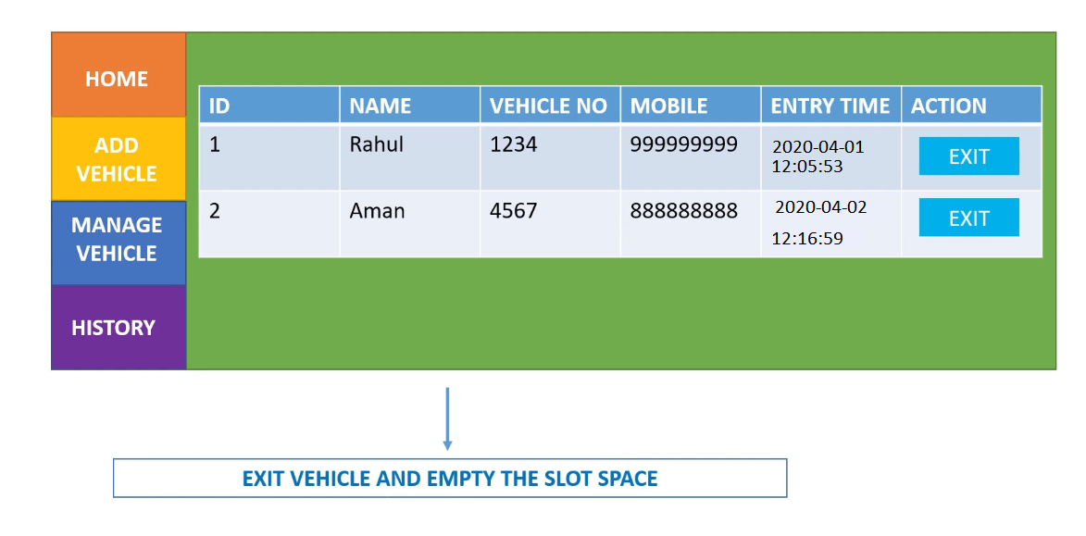

**History-**

In this module use can see the history of vehicles(E.g.- Name, vehicle number, Mobile number, entry time and exit time).

